SAVEETHA SCHOOL OF ENGINEERING

CSA1404
COMPILER DESIGN LAB MANUAL

Shivaji V
192424370

Q1) Develop a lexical Analyzer to identify identifiers, constants, operators using C program.

Output
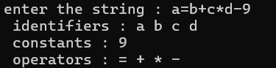

Q2) Develop a lexical Analyzer to identify whether a given line is a comment or not using C.

Output
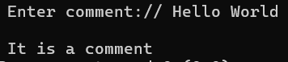

Q3) Design a lexical Analyzer for given language should ignore the redundant spaces, tabs and new lines and ignore comments using C.

Output
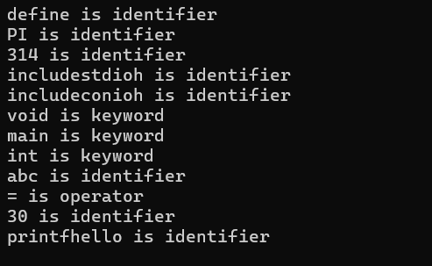

Q4) Design a lexical Analyzer to validate operators to recognize the operators +,-,*,/ using regular arithmetic operators using C.
Output
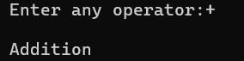
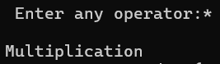

Q5) Design a lexical Analyzer to find the number of whitespaces and newline characters using C.
Output
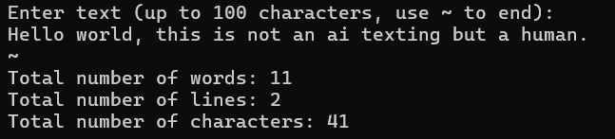

Q6) Develop a lexical Analyzer to test whether a given identifier is valid or not using C.
Output
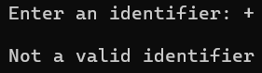

Q7) Write a C program to find FIRST( ) - predictive parser for the given grammar

Output
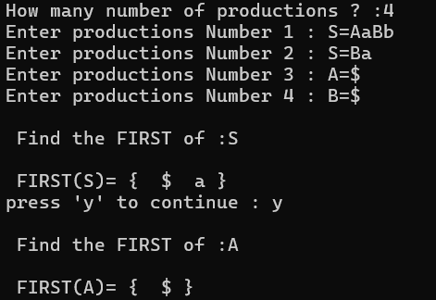

Q8) Write a C program to find FOLLOW( ) - predictive parser for the given grammar.

Output
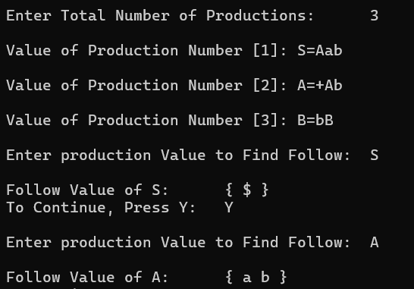

Q9) Implement a C program to eliminate left recursion from a given CFG.
Output
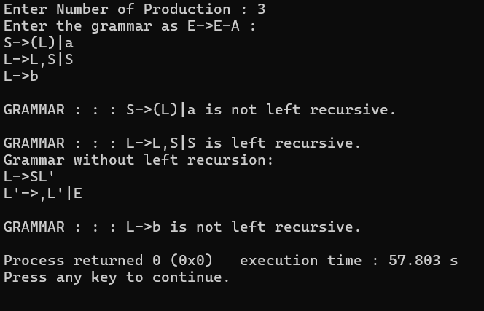

Q10) Implement a C program to eliminate left factoring from a given CFG.
Output
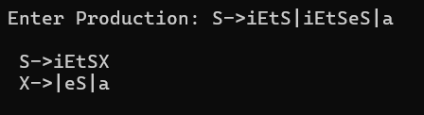

Q11) Implement a C program to perform symbol table operations.

Output
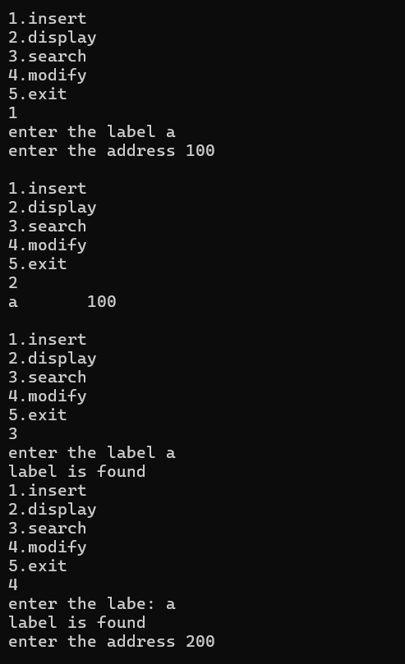

Q12) Write a C program to construct recursive descent parsing for the given grammar.
Output
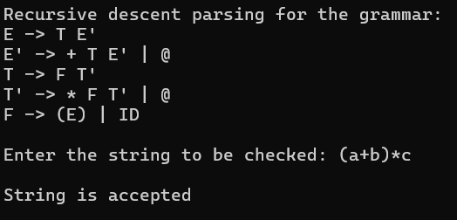

Q13) Write a C program to implement either Top Down parsing technique or Bottom Up Parsing technique to check whether the given input string is satisfying the grammar or not.
Output
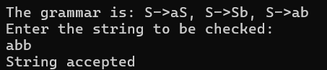

Q14) Implement the concept of Shift reduce parsing in C Programming.
Output
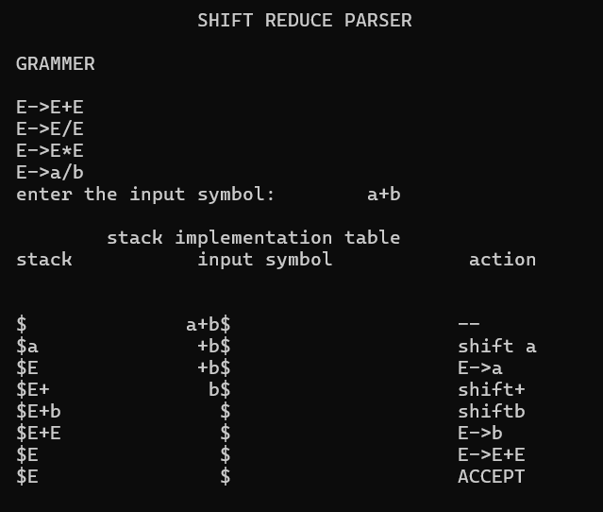

Q15) Write a C Program to implement the operator precedence parsing.
Output
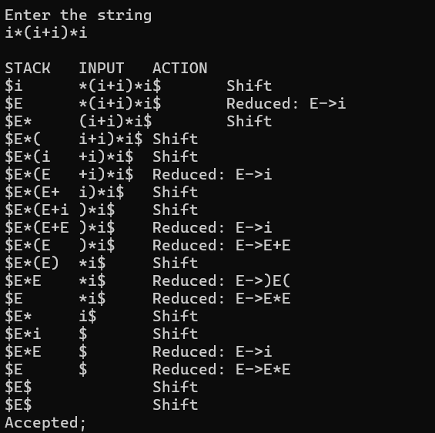

Q16) Write a C Program to Generate the Three address code representation for the given input statement.
Output
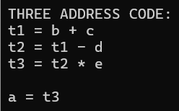

Q17) Write a C program for implementing a Lexical Analyzer to Scan and Count the number of characters, words, and lines in a file.
Output
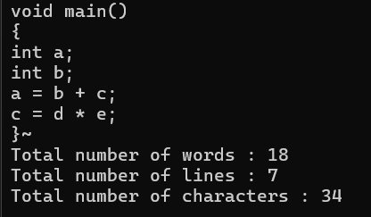

Q18) Write a C program to implement the back end of the compiler.
Output
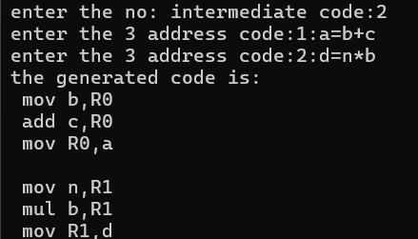

Q19) Write a C program to compute LEADING( ) – operator precedence parser for the given grammar.
Output
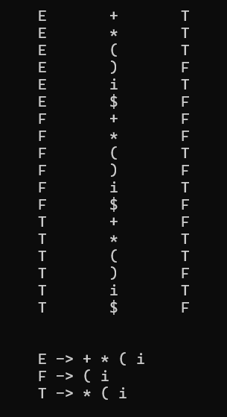

Q20) Write a C program to compute TRAILING( ) – operator precedence parser for the given grammar.
Output
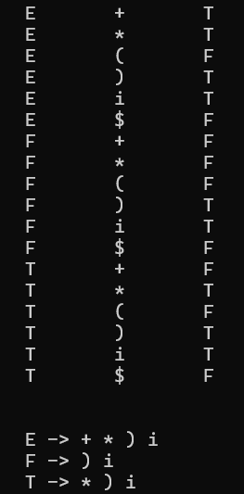

Q21) Write a LEX specification file to take input C program from a .c file and count the number of characters, number of lines & number of words.
%{
int nchar, nword, nline;
%}
%%
\n { nline++; nchar++; }
[^ \t\n]+ { nword++, nchar += yyleng; }
. { nchar++; }
%%
int yywrap(void) {
return 1;
}
int main(int argc, char *argv[]) {
yyin = fopen(argv[1], "r");
yylex();
printf("Number of characters = %d\n", nchar);
printf("Number of words = %d\n", nword);
printf("Number of lines = %d\n", nline);
fclose(yyin);
}
Output
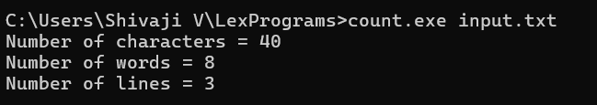

Q22) Write a LEX program to print all the constants in the given C source program file.
%{
int cons = 0;
%}
%%
[0-9]+ { cons++; printf("%s is a constant\n", yytext); }
.|\n { }
%%
int yywrap(void) { return 1; }
int main(void)
{
FILE *f;
char file[50];
printf("Enter File Name : ");
scanf("%s", file);
f = fopen(file, "r");
yyin = f;
yylex();
printf("Number of Constants : %d\n", cons);
fclose(f);
return 0;
}
Output
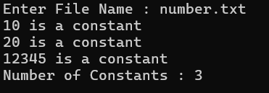

Q23) Write a LEX program to count the number of Macros defined and header files included in the C program.
%{
#include <stdio.h>
int macros = 0, headers = 0;
%}
%%
"#define" { macros++; }
"#include" { headers++; }
.|\n { }
%%
int yywrap() { return 1; }
int main(int argc, char *argv[]) {
yyin = fopen(argv[1], "r");
yylex();
printf("Macros = %d\n", macros);
printf("Headers = %d\n", headers);
return 0;
}
Output
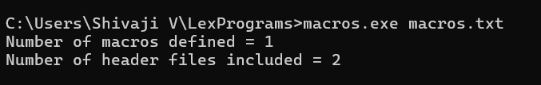

Q24) Write a LEX program to print all HTML tags in the input file
%{
int tags;
%}
%%
"<"[^>]*> { tags++; printf("%s \n", yytext); }
.|\n { }
%%
int yywrap(void) {
return 1; }
int main(void)
{
FILE *f;
char file[10];
printf("Enter File Name : ");
scanf("%s",file);
f = fopen(file,"r");
yyin = f;
yylex();
printf("\n Number of html tags: %d",tags);
fclose(yyin);
}
Output
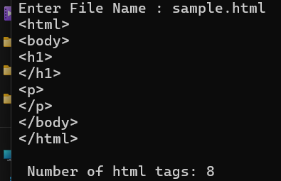
Q25) Write a LEX program which adds line numbers to the given C program file and display the same in the standard output.
%{
int yylineno;
%}
%%
^(.*)\n printf("%4d\t%s", ++yylineno, yytext);
%%
int yywrap(void) {
return 1;
}
int main(int argc, char *argv[]) {
yyin = fopen(argv[1], "r");
yylex();
fclose(yyin);
}
Output
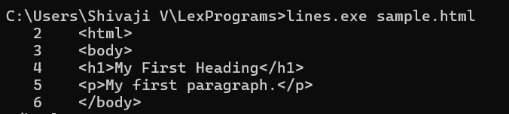

Q26) Write a LEX program to count the number of comment lines in a given C program and eliminate them and write into another file.
%{
int com=0;
%}
%s COMMENT
%%
"/*" {BEGIN COMMENT;}
<COMMENT>"*/" {BEGIN 0; com++;}
<COMMENT>\n {com++;}
<COMMENT>. {;}
\/\/.* {; com++;}
.|\n {fprintf(yyout,"%s",yytext);}
%%
void main(int argc, char *argv[])
{
if(argc!=3)
{
printf("usage : a.exe input.c output.c\n");
exit(0);
}
yyin=fopen(argv[1],"r");
yyout=fopen(argv[2],"w");
yylex();
printf("\n number of comments are = %d\n",com);
}
int yywrap()
{
return 1;
}

Output
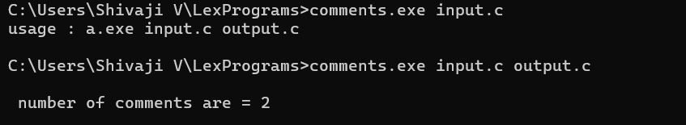

Q27) Write a LEX program to identify the capital words from the given input.
%%
[A-Z]+ { printf("%s is a capital word\n", yytext); }
.|\n|\t| " " { }
%%

int main() {
printf("Enter String:\n");
yylex();
return 0;
}
int yywrap() { return 1; }
Output
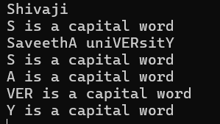

Q28) Write a LEX Program to check the email address is valid or not.
%{
#include <stdio.h>
int valid = 0;
%}
%%
^[a-zA-Z0-9_.]+@[a-zA-Z0-9_.]+\.[a-zA-Z]+$ {
valid = 1;
return 0;
}
.|\n { }
%%
int yywrap() { return 1; }
int main() // Removed (argc, argv)
{
// yyin is implicitly set to stdin (keyboard)
yylex();
if(valid)
printf("Valid Email\n");
else
printf("Invalid Email\n");
return 0;
}
Output
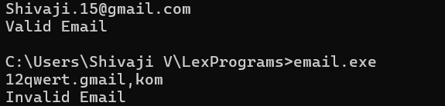

Q29) Write a LEX Program to convert the substring abc to ABC from the given input string
%{
int i;
%}
%%
[a-z A-Z]* { for(i=0;i<=yyleng;i++)
{ if((yytext[i]=='a')&&(yytext[i+1]=='b')&&(yytext[i+2]=='c'))
{ yytext[i]='A';
yytext[i+1]='B';
yytext[i+2]='C';
}
}
printf("%s",yytext);
}
[\t]* return 1;
.* {ECHO;}
\n {printf("%s",yytext);}
%%
int main()
{
yylex();
}
int yywrap()
{
return 1;
}
Output
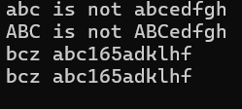

Q30) Implement a LEX program to check whether the mobile number is valid or not.
%%
[0-9]+ { printf("\nValid digit\n"); }
.* { printf("\nInvalid digit\n"); }
%%
int yywrap() { return 1; }
int main() {
yylex();
return 0;
}
Output
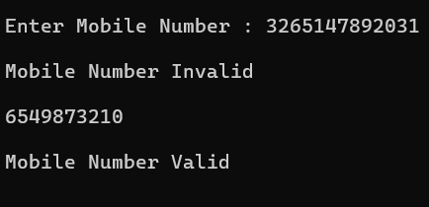

Q31) Implement Lexical Analyzer using FLEX (Fast Lexical Analyzer). The program should separate the tokens in the given C program and display with appropriate caption.

digit [0-9]
letter [A-Za-z]
%{
int count_id,count_key;
%}
%%
(stdio.h|conio.h) { printf("%s is a standard library\n",yytext); }
(include|void|main|printf|int) { printf("%s is a keyword\n",yytext); count_key++; }
{letter}({letter}|{digit})* { printf("%s is a identifier\n", yytext); count_id++; }
{digit}+ { printf("%s is a number\n", yytext); }
\"(\\.|[^"\\])*\" { printf("%s is a string literal\n", yytext); }
.|\n { }
%%
int yywrap(void) {
return 1;
}
int main(int argc, char *argv[]) {
yyin = fopen(argv[1], "r");
yylex();
printf("number of identifiers = %d\n", count_id);
printf("number of keywords = %d\n", count_key);
fclose(yyin);
}

Output
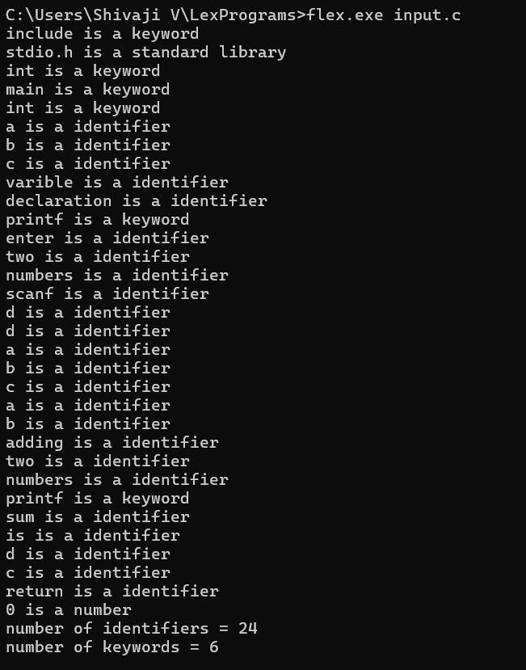

Q32) Write a LEX program to count the number of vowels in the given sentence.
%{
#include <stdio.h>
int v = 0;
%}
%%
[aeiouAEIOU] { v++; }
.|\n { }
%%
int yywrap() { return 1; }
int main(int argc, char *argv[]) {
yyin = fopen(argv[1], "r");
yylex();
printf("Vowels = %d\n", v);
return 0; }

Output
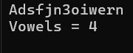

Q33) Write a LEX program to separate the keywords and identifiers.

digit [0-9]
letter [A-Za-z]
%{
int count_id,count_key;
%}
%%
(stdio.h|conio.h) { printf("%s is a standard library\n",yytext); }
(include|void|main|printf|int) { printf("%s is a keyword\n",yytext); count_key++; }
{letter}({letter}|{digit})* { printf("%s is a identifier\n", yytext); count_id++; }
{digit}+ { printf("%s is a number\n", yytext); }
\"(\\.|[^"\\])*\" { printf("%s is a string literal\n", yytext); }
.|\n { }
%%
int yywrap(void) {
return 1;
}
int main(int argc, char *argv[]) {
yyin = fopen(argv[1], "r");
yylex();
printf("number of identifiers = %d\n", count_id);
printf("number of keywords = %d\n", count_key);
fclose(yyin);
}

Output
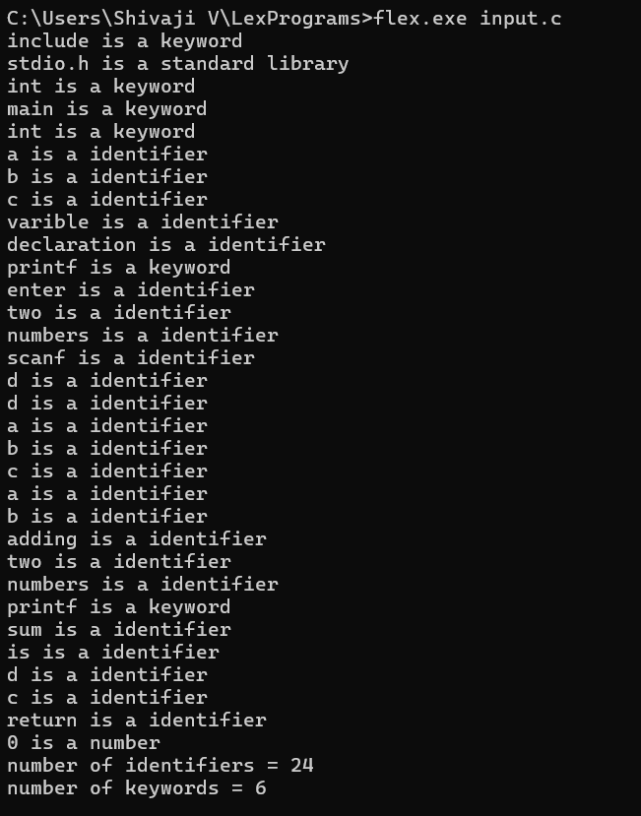

Q34) Write a LEX program to recognise numbers and words in a statement
%%
[\t ]+ ;
[0-9]+|[0-9]*\.[0-9]+ { printf("\n%s is NUMBER", yytext);}
#.* { printf("\n%s is COMMENT", yytext);}
[a-zA-Z]+ { printf("\n%s is WORD", yytext);}
\n { ECHO;}
%%
int main()
{
while( yylex());
}
int yywrap( )
{
return 1;
}
Output
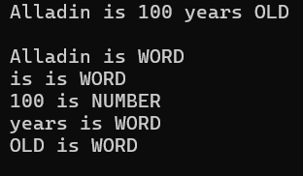

Q35) Write a LEX program to identify and count positive and negative numbers.
%{
#include <stdio.h>
int pos = 0, neg = 0;
%}
%%
-[0-9]+ { neg++; printf("Negative : %s\n", yytext); }
\+?[0-9]+ { pos++; printf("Positive : %s\n", yytext); }
.|\n { }
%%
int yywrap() { return 1; }
int main(int argc, char *argv[]) {
yyin = fopen(argv[1], "r");
yylex();
printf("\nTotal Positive Numbers = %d\n", pos);
printf("Total Negative Numbers = %d\n", neg);
return 0;
}

Output
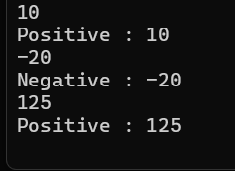

Q36) Write a LEX program to validate the URL.
%%
((http)|(ftp))s?:\/\/[a-zA-Z0-9](.[a-z])+(.[a-zA-Z0-9+=?]*)* {printf("\nURL Valid\n");}
.+ {printf("\nURL Invalid\n");}
%%
void main()
{
printf("\nEnter URL : ");
yylex();
printf("\n");
}
int yywrap()
{
}
Output
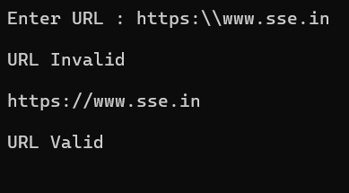

Q37) Write a LEX program to validate DOB of students
%%
((0[1-9])|([12][0-9])|(3[01]))\/((0[1-9])|(1[0-2]))\/(19[0-9]{2}|2[0-9]{3}) { printf("Valid DoB\n"); }
.* { printf("Invalid DoB\n"); }
%%

int main() {
yylex();
return 0;
}
int yywrap() { return 1; }

Output
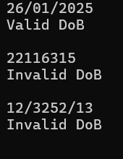

Q38) Write a LEX program to check whether the given input is digit or not.
%%
[0-9]+ { printf("\nValid digit\n"); }
.* { printf("\nInvalid digit\n"); }
%%
int yywrap() { return 1; }
int main() {
yylex();
return 0;
}
Output
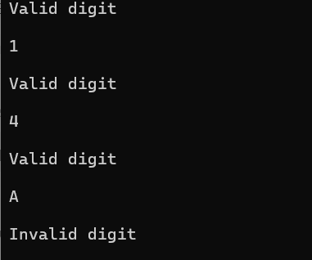

Q39) Write a LEX program to implement basic mathematical operations.
%{
#include <stdio.h>
int a, b;
%}
%%
([0-9]+)\+([0-9]+) { sscanf(yytext, "%d+%d", &a, &b); printf("Result = %d\n", a + b); }
([0-9]+)\-([0-9]+) { sscanf(yytext, "%d-%d", &a, &b); printf("Result = %d\n", a - b); }
([0-9]+)\*([0-9]+) { sscanf(yytext, "%d*%d", &a, &b); printf("Result = %d\n", a * b); }
([0-9]+)/([0-9]+) { sscanf(yytext, "%d/%d", &a, &b);
if(b == 0) printf("Cannot divide by zero\n");
else printf("Result = %d\n", a / b);
}
.* { }
%%
int yywrap() { return 1; }
int main() {
yylex();
return 0;
}

Output
